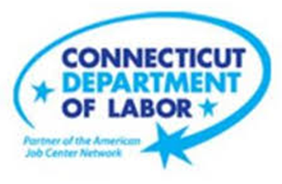

**NEW WEEKLY JOB POSTINGS FROM   
HELP WANTED ONLINE  
Office of Research**

**Week Ending November 4th, 2023: Total New Ads Rebound to a Four Month High**  
WETHERSFIELD, November 8th, 2023 – During the week ending November 4th, there were 6,987 new job postings in Connecticut. This weekly total is up 1,816 new ads from a week ago and the highest weekly level in over four months. Ninteen of twenty-one industries had over-the-week increases and two decreased. Thirty-one percent of the the over the week increase occurred in Administrative & Support Services (12%), Professional, Scientific and Technical Services (10%) and Manufacturing (9%). The employers with the most new ads in these respective industries were Actalent (62 new ads), CDM Smith (51 new ads), and Intel (93 new ads). The graph below illustrates overall new ads count statewide from July 8th Through November 4th. During that span, weekly new ads ranged from 4,820 new ads (10/14/23) and the current week of 6,897.  
  
 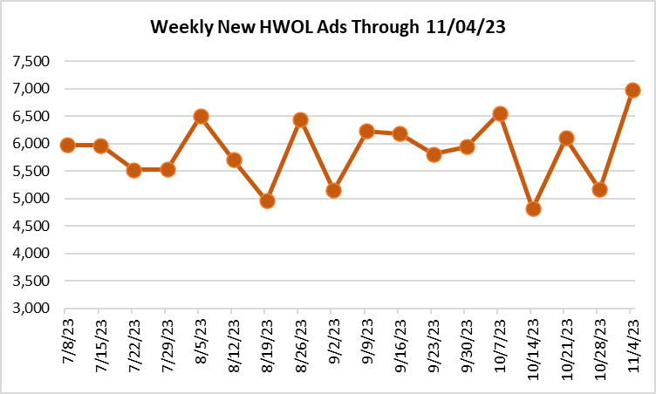  
  
  
  
**Industries** with the most new postings include Health Care & Social Assistance, Manufacturing, and Retail Trade.

**Occupations** with the most new postings include Registered Nurses, Retail Salespersons, and Supervisors of Retail Sales Works.

**Employers** with the most new postings include Yale New Haven Health, Middlesex Health System, State of Connecticut.

**New Weekly Job Postings by Industry**  
**The three industries with the most new job postings were:**

* **Health Care & Social Assistance** (1,059 new postings, +8% over the week)
* **Manufacturing** (637 new postings, +34% over the week)
* **Retail Trade** (581 new postings, 8% over the week)



For more information on total monthly job ads in Connecticut and its labor market areas, see the monthly report available here: <https://www1.ctdol.state.ct.us/lmi/hwol.asp>

 The above table highlights the 25 occupations with the most new job ads during the week ending November 4th, 2023. During that week, employers posted new job ads for over 700 specific occupations in the state. The 25 occupations account for 38% of the 6,987 new ads during the week. The three occupations with the most new ads were Registered Nurses (282 new ads), Retail Salespersons (276 new ads), and Supervisors of Retail Sales Workers (189 new ads). Employers with the most job ads for those three occupations respectively are Yale New Haven Health (87 new ads), TJX 18 new ads), and CVS Health (22 new ads). Among the 25 occupations with the most new ads, the median annual salary ranged from $34,432 (Fast Food and Counter Workers) to $135,680 (Software Devlopers).

**Employers with the Most New Job Postings**compass group kpmg   
Employers with the most new job postings during the week ending November 4th, 2023 were mostly within Retail Trade, Healthcare, and Administrative & Support. The employers with the most ads in those respective industries were Yale New Haven Health (237 new ads), Pep Boys (48 new ads), and Compass Group (23 new ads). Eightteen employers in the top 25 had over the week new ad increases, one was unchanged, and six declined. The largest over-the-week increase among the 25 employers occurred at Yale New Haven Health (+87 new ads) and the largest decrease occurred at Hartford Healthcare (-170 new ads).   
 **What is HWOL?**The **Conference Board Help Wanted Online**® Data Series (HWOL) measures the number of new, first-time Online job postings and jobs reposted from the previous month for over 16,000 Internet job boards, corporate boards, and smaller job sites that serve niche markets and smaller geographic areas. To view more HWOL data, go to: <https://www1.ctdol.state.ct.us/lmi/hwol.asp>